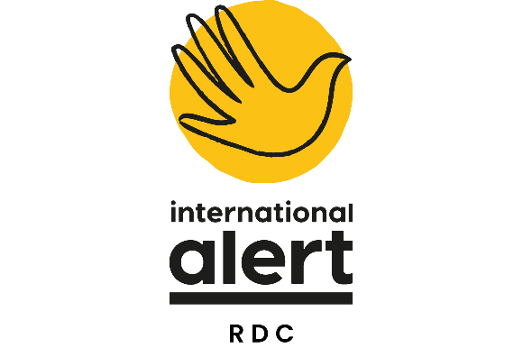
CONSULTANT – INTERIM SUPPORT
Consultancy | Interim Director of Programmes DRC
Reports to | Country Director
Management Responsibility | Direct line management responsibility for:  - 1 deputy director of programmes  - 1 DMEAL Manager  - 3 Chiefs of Party level positions  - 2 Senior Advisors/DCOPs
Location | Remote/Goma or Bukavu, DRC
Number of days per month | 20 days per month  Period of 3 months  15 September – 15 December

Justification for the consultancy
International Alert DRC is undergoing a management transition and is currently hiring for a new Director of Programmes. Given the seniority of the post and complexity of the role, the mission is likely to have a gap of 3 – 4 months while the postholder arrives. We are looking to recruit short term support in the interim to support the Country Programme.

The Interim Director of Programmes will be responsibility for leading the development of Alert’s programme strategy and of new peacebuilding initiatives. S/he will work closely with the Country Director on the development of new project ideas and the identification of new funding opportunities and new partnerships. S/he will work with the Deputy Director of Programmes to ensure effective programme management to maximise impact through cross-learning, quality control and appropriate advocacy and visibility for the programme.

It is ideal that the interim DoP be based in Goma or Bukavu during this time; if the consultant is not based for the full 21 days per month in DRC, they will be required to undertake 2 – 3 missions of 3 – 4 weeks to provide programme support during this time given the programmes’ needs.

Deliverables
1. Lead on programme strategy and impact in DRC
- Provide strategic guidance for design of 1 – 2 new projects so they are relevant, likely to produce impact, feasible and financially sustainable
- Carry out monthly budget check ins on all projects ; work with Director of Finance and Deputy Director of Programmes to oversee the programme budget, ensure that forecasts at country level are accurate and promote effective grants management and programme sustainability;
- Oversee programme implementation in line with contractual requirements and with a high level technical quality through line management of the Deputy Director of Programmes.

2. Lead on new projects, fundraising & regional synergies
- Support the development of 2 – 3 new concept notes (lead on technical inputs, methodologies, strategies, choice of location and partners, structural set-up etc).;
- With support from the Deputy Director of Programmes, ensure that monthly regional coordination meetings are taking place, take the lead on programming steering committees for regional projects and propose mechanisms for improved collaboration;
- Lead on strategic level coordination of regional projects with neighbouring Alert country programmes during the interim period; trouble shoot and work with senior management in other country programmes to ensure smooth implementation of regional projects during the interim period.

- Provide quality control and support for strong MEL, research and programme level advocacy
- Provide strategic guidance to research activities ongoing at project and programme level;
- Develop communications priorities for each of the programme’s projects for the coming 12 months and support their implementation together with the Country Director, Deputy Director of Programmes and other programme staff, as well as Alert’s global communications team, in the interim period.
- Lead on strategic programme level learning within the DRC programme to generate a shared responsibility for the programme’s achievements and impacts; specifically developing learning reports and planning the 2024 Annual Reflection Session to be held in December
- Organise peacebuilding learning activities, such as thematic working groups, staff training and programme team retreats.
- Work closely with finance and operations teams to contribute to strong interdepartmental collaboration and resolve blockages.
- Ensure the strategic direction of programmatic management of the Alert RDC program portfolio through results and research-based approaches.
- Provides the final review of annual reports of projects and submits them for CD approval.

- Ensure representation and effective overall partnership management
- Attend Steering committees for Consortium projects, giving technical input and managing the Chief of Party where Alert is the lead agency.

PERSON SPECIFICATION
ESSENTIAL REQUIREMENTS
University degree in a relevant field
At least 10 years’ experience of working in a variety of conflict contexts in positions with management responsibilities
Proven expertise of supervising and developing peacebuilding strategies and understanding of gender- and conflict-sensitive approaches. Experience in managing programme/country level research projects.
Extensive experience and interest in managing and motivating staff and facilitating staff growth
Extensive experience and interest in programme budget management, forecasting and effective programme level budget management
Understanding of MEL techniques and using them to inform programme design/strategy
Track record of working in multi-agency consortium projects with a variety of local partners and different components.
Previous experience of successful fundraising, including donor liaison and proposal-writing
Highly organised with excellent planning and coordination skills
Fluency in French and English.
Excellent communications skills with a diverse range of people and an ability to deal with sensitive issues in a tactful way.
An ability to handle stressful situations and intense work periods; a willingness to improvise and adapt
Previous experience of working in the Great Lakes region.

