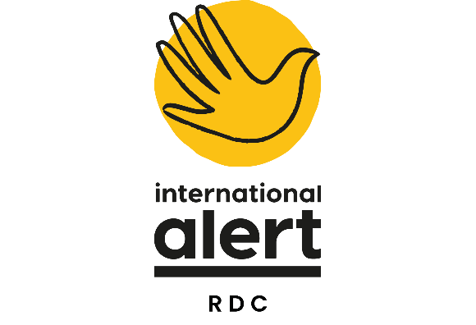

**JOB DESCRIPTION**

|  |  |
| --- | --- |
| **Job Title** | Director of Programmes DRC |
| **Reports to** | Country Director |
| **Management Responsibility** | Direct line management responsibility for:   * 1 deputy director of programmes * 1 DMEAL Manager * 3 Chiefs of Party level positions * 2 Senior Advisors/DCOPs |
| **Job location** | Bukavu, DRC |
| **Grade** | 3A |
| **Duration** | 1 year fixed term |

|  |
| --- |
| **Job Purpose** |
| The post holder leads the development of Alert’s programme strategy and of new peacebuilding initiatives. S/he will work closely with the Country Director on the development of new project ideas and the identification of new funding opportunities and new partnerships.  S/he will work with the Deputy Director of Programmes to ensure effective programme management to maximise impact through cross-learning, quality control and appropriate advocacy and visibility for the programme. S/he will work with Alert’s Africa Programme (AP), and with other Alert offices in the Great Lakes region, taking an active role in broader regional strategy and cross-programmatic activities. |
| **Duties and Responsibilities** |
| **This post focuses on the following key elements:**   * Development of programme strategy and quality control; * Development of new programming, fundraising and new partnerships; * Support for strong MEL and advocacy; * Ensure cross-learning and complementarity with other country programmes in the Great Lakes region; * Contribute to activities of the Africa programme (AP) and the wider organisation. |
| **1**. **Lead on programme strategy and impact in DRC**   * Co-develop and lead on the technical aspects of the DRC country strategy, in co-operation with the Country Director * Provide strategic guidance for design of new projects so they are relevant, likely to produce impact, feasible and financially sustainable; * Work with Director of Finance and Deputy Director of Programmes to oversee the programme budget, ensure that forecasts at country level are accurate and promote effective grants management and programme sustainability; * Oversee programme implementation in line with contractual requirements and with a high level technical quality through line management of the Deputy Director of Programmes.   **2. Lead on new projects, fundraising & regional synergies**   * Propose new projects and draft concept notes (lead on technical inputs, methodologies, strategies, choice of location and partners, structural set-up etc.; * With support from the Deputy Director of Programmes, build cross-regional project activities and improved collaboration; * Lead on strategic level coordination of regional projects with neighbouring Alert country programmes; feed into design of regional governance structures and participate in regional steering committees; trouble shoot and work with senior management in other country programmes to ensure smooth implementation of regional projects. * Contribute to and attend events of the Great Lakes programme; develop and nurture joint ventures with London-based departments, where opportune.  1. **Provide quality control and support for strong MEL, research and programme level advocacy**  * Manage the MEL Manager to support effective MEL and draw on best practice to review and develop new MEL techniques; * Provide strategic guidance to research activities ongoing at project and programme level; * Work with the Country Director, Deputy Director of Programmes and other programme staff, as well as Alert’s global communications team, to ensure new methodologies and best practice are documented and disseminated. * Identify policy priorities/advocacy opportunities/target audiences for programme level advocacy objectives and lead on these advocacy campaigns in coordination with the Country Director; * Lead on strategic programme level learning within the DRC programme to generate a shared responsibility for the programme’s achievements and impacts; * Organise peacebuilding learning activities, such as thematic working groups, staff training and programme team retreats. * Work closely with finance and operations teams to contribute to strong interdepartmental collaboration and resolve blockages. * Ensure the strategic direction of programmatic management of the Alert RDC program portfolio through results and research-based approaches. * Provides the final review of annual reports of projects and submits them for CD approval; signs off on quarterly and semi-annual reports.  1. **Ensure representation and effective overall partnership management**  * Maintain and develop relations with a network of Congolese government officials and civil society contacts, as well as key members of the international community; lead on political engagement at provincial level in all provinces where Alert is implementing programmes; * Lead on the identification and mapping of new local/international partners and designation of strategic partners. * Attend Steering committees for Consortium projects, giving technical input and managing the Chief of Party where Alert is the lead agency.  1. **Contribution to wider organisational goals**  * Contribute to the AP’s strategic planning processes and participate in wider organisational strategic thinking; * Coordinate with relevant Country Directors to ensure coordination and cross-learning at the regional Great Lakes level. |
| **Travel requirements** |
| Within the DRC, regular travel to the field and occasionally to Kinshasa and within the Great Lakes Region. |

**PERSON SPECIFICATION**

**ESSENTIAL REQUIREMENTS**

|  |
| --- |
| **Talents** |
| At Alert, we have introduced Talent Management to our business model as we believe talented people are crucial to the success of our work. We believe all individuals are talented and success comes in matching the right talents to the right roles. For this role, the skills, qualifications and experience listed below are important, but we believe that to be great in this job you are likely, first and foremost, to have a talent for supervising and developing peacebuilding projects. This will require solid technical expertise in the peacebuilding field, strong management experience coupled with planning, communication and interpersonal skills and soft skills such as sense of diplomacy, empathy, cultural sensitivity and ability to deal with various stakeholders (donors, government representatives, partners etc). |
| University degree in a relevant field |
| At least 10 years’ experience of working in a variety of conflict contexts in positions with management responsibilities |
| Proven expertise of supervising and developing peacebuilding strategies and understanding of gender- and conflict-sensitive approaches. Experience in managing programme/country level research projects. |
| Extensive experience and interest in managing and motivating staff and facilitating staff growth |
| Extensive experience and interest in programme budget management, forecasting and effective programme level budget management |
| Understanding of MEL techniques and using them to inform programme design/strategy |
| Track record of working in multi-agency consortium projects with a variety of local partners and different components. |
| Previous experience of successful fundraising, including donor liaison and proposal-writing |
| Highly organised with excellent planning and coordination skills |
| Fluency in French and English. |
| Excellent communications skills with a diverse range of people and an ability to deal with sensitive issues in a tactful way. |
| An ability to handle stressful situations and intense work periods; a willingness to improvise and adapt |
| Previous experience of working in the Great Lakes region. |

**DESIREABLE REQUIREMENTS**

|  |
| --- |
| An existing network of contacts in DRC |