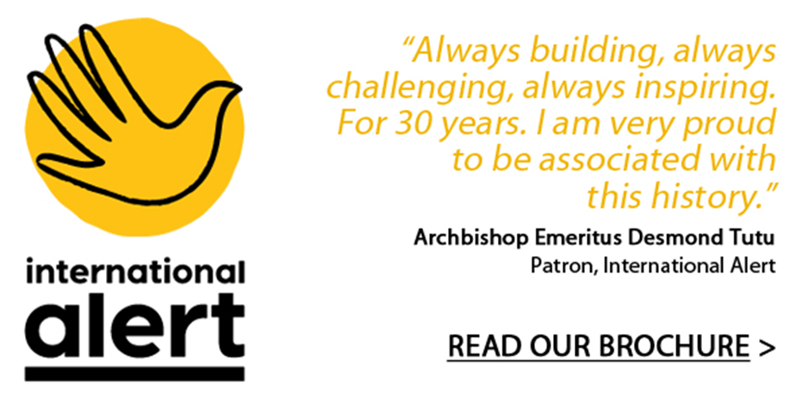

**JOB DESCRIPTION**

|  |  |
| --- | --- |
| **Job Title** | **Head of Communications and Media** |
| **Reports to** | **Director of Policy, Advocacy and Communications** |
| **Management Responsibility** | **3 staff members, occasional consultants, interns and volunteers; functional supervision of communications staff in programme/country teams** |
| **Job location** | **London** |
| **Grade and level** | **2** |
| **Contract Duration** | **Permanent** |

|  |
| --- |
| **Job Purpose** |
| The Head of Communications and Media is responsible for leadership of International Alert’s Communications function, leading development and delivery of Alert’s communications strategy for the next three years. The postholder will drive and shape communications activity for Alert, expanding our reach and impact. They will be responsible for Alert’s media work, developing and maintaining relationships with journalists, and growing our media profile both nationally and globally, in a range of outlets. They will represent the organisation externally, developing relationships with partner organisations, sharing strategy and ideas and co-ordinating joint projects. They will play a proactive role advising senior leadership within Alert on responding to breaking news and identifying opportunities to raise Alert’s profile, and advise on communications in a crisis. They will understand the requirements of Alert’s programmatic and advocacy work, working in collaboration with staff across the organisation to develop campaigns that meet objectives in these areas. They will build relationships with Alert’s key funders, developing an understanding of their expectations and guiding the team to deliver against those. They will support the team to take a more proactive approach to Alert’s communications, spearheading a strategic approach that is impactful and measurable. |
| **Duties and Responsibilities** |
| **Strategy and planning**   * Develop and implement a three year communications strategy for Alert, in line with the organisational strategy, ensuring consultation and collaboration with Alert’s global and country teams * Work closely with country teams to support the development of in-country communications strategies, ensuring regular co-ordination with country level communications colleagues * Set clear objectives and KPIs for Alert’s communications work, developing robust frameworks for monitoring and reporting, and linking these to delivery of the communications strategy   **Media relations**   * Develop and deliver a media strategy, in line with Alert’s programme priorities, influencing and funding strategies; * Lead on cultivating new and foster existing relations with key contacts in the media, building Alert’s credibility and ensuring effective working relationships with journalists; * Lead on delivery of media strategy for discrete projects, developing plans, drafting key messages and press releases, identifying and working with target journalists and setting parameters for success. * Lead on Alert’s response to breaking news stories and events, working with senior staff to develop appropriate responses * Lead on crisis communications for Alert, drafting and holding the crisis communications protocol, representing the communications team on the Crisis Management Group, supporting and advising senior staff, and ensuring regular media training for relevant staff * Proactively identify opportunities for coverage of Alert’s work in UK, European and international media, as well as by national/regional media in countries/regions where Alert works, and maximise profile opportunities for Alert’s spokespeople and experts; * Manage and monitor the media email account and media phone, including out-of-hours media calls.   **Content, branding and profile**   * Ensure robust sign-off processes, comprehensive policies and quality systems to facilitate the work of programme and/or country teams and to ensure that all Alert’s communications are consistent with Alert’s brand, coherent in tone and messages, and high in quality; * Lead a brand review for Alert in line with the new organisational strategy, including robust audience testing * Oversee the maintenance and implementation of Alert’s brand guidelines, supporting the marketing and publications officer to ensure brand consistency across all of Alert’s work * Work collaboratively with other organisations and deepen relationships with donors and funders to increase the profile and visibility of Alert and the peacebuilding sector.   **Events and outreach**   * Ensure excellent profiling and positioning of Alert’s brand, image and impact throughout Alert’s external communications and events; * Oversee the design, planning and implementation of specific activities or events and campaigns using a variety of media, and ensure that opportunities for contributing to Alert’s funding, media and influencing strategies and building/maintaining excellent relations with potential supporters and contacts are optimised for each event; * Ensure that all Alert outputs are disseminated successfully, using different media and messages to reach out to and engage different target audiences, and that dissemination strategies and budgets are set for each output.   **Digital communications**   * Support the Senior Digital Engagement Officer to develop an annual content plan that reflects the requirements of the strategy and delivers against its objectives * Maintain understanding of and engagement with the latest digital trends and approaches, ensuring Alert is compliant with relevant regulations * Oversee the development of a digital plan and ensure it contributes to Alert’s programme priorities, influencing and funding strategies; * Ensure the furthering of Alert’s reach and profile through more effective and targeted use of the website, digital marketing and social media channels   **Programmatic communications**   * Support programme and country teams in strengthening their communications and outreach, and facilitate the development of their own communications and influencing strategies; * Identify deficiencies and gaps in programmes’ communications capacity, skills and materials and make plans to remedy them as appropriate; * Ensure that quality trainings are provided for programmes, country teams and partner organisations on relevant aspects of communications; * Provide quality technical assistance and advice to programme and country teams for project planning, proposals and reporting, ensuring communications is incorporated into programme design and budgets.   **Line management, budget management and organisational leadership**   * Line manage the Communications team staff, and interns, volunteers and consultants where appropriate, setting clear and manageable workplans, ensuring structured, regular support and supervision, and tailored personal development plans; * Ensure strong team co-ordination and support, with regular team meetings and awaydays * Accompany, mentor and functionally supervise communications staff in programmes teams; * Set, manage and monitor the Advocacy and Communications budget, ensuring robust oversight of spend and adherence to finance and procurement policies; * Work closely with the Director of Policy, Advocacy and Communications to review and strengthen communications strategy and delivery, developing strong relationships with the Senior Policy and Advocacy Officer and the GPU Director to ensure advocacy and communications objectives are co-ordinated and complementary; * Ensure efficient team-wide communications and knowledge management, and contribute to organisation-wide communications, knowledge management, events and discussions on related topics/projects; * Deputise for the Director of Policy, Advocacy and Communications where appropriate. |
| **Travel requirements** |
| The post-holder should be prepared to undertake some travel internationally to areas of instability, as well as travel within the UK and Europe. |

**PERSON SPECIFICATION**

|  |
| --- |
| **Talents** |
| At Alert, we have introduced Talent Management to our business model as we believe talented people are crucial to the success of our work. We believe all individuals are talented and success comes in matching the right talents to the right roles. At Alert, we have introduced Talent Management to our business model as we believe talented people are crucial to the success of our work. We believe all individuals are talented and success comes in matching the right talents to the right roles. For this role, the skills, qualifications and experience listed below are important, but we believe that to be great in this job you are likely, first and foremost, to have a vision for how Alert can maximise the impact of its peacebuilding work through its communications. You’ll be a strategic thinker with the ability to see the potential in the stories we are able to tell and the people and partners we work with. You’ll have good political nous, be creative and thoughtful, with the ability to work with a diverse range of people across the world.  This is what we will be looking for above all else. |

**ESSENTIAL REQUIREMENTS**

|  |
| --- |
| Experience in a communications leadership role |
| Experience developing communications strategy and of monitoring and assessing communications reach and impact |
| Knowledge and experience of UK and international media, with an understanding of what makes a strong news story and good contacts |
| Understanding of the interface between communications and advocacy, and between communications and fundraising, and experience of incorporating this into planning communications work |
| Fluent and articulate in English, both spoken and written, to the highest standard |
| Excellent interpersonal skills with experience of working with people of all levels and backgrounds both within and outside the organisation, and ability to advise senior staff |
| Experience of managing crisis communications |
| A track record of delivering growth in impact and engagement across multiple channels |
| Experience of ensuring brand compliance across different communications channels, and knowledge of branding and brand principles |
| Tech savvy, with knowledge/understanding of CMS, and experience of driving digital communications |
| Experience of managing budgets and incorporating communications into project design |
| Line management experience with the ability to lead, motivate and support staff |
| Ability to work to tight deadlines and balance competing demands |

**DESIRABLE REQUIREMENTS**

|  |
| --- |
| Specialist knowledge of peacebuilding through either professional experience or academic study or both |
| Knowledge of French, Russian or Arabic |
| Experience raising funds for communications work/activities/projects |
| Experience designing/implementing political or behavioural change campaigns |
| Experience working on media for peace or communications for development projects |
| Strong US media contacts |
| Knowledge of advocacy |
| Knowledge of CSS/HTML and/or of SEO and UX |